**Lesson 10 Demo 3**

**Deploying a Docker Container with Jenkins Pipelines**

Steps to be followed:

1. Log in to Jenkins CI tool and Install Docker and Docker Pipeline Plugin
2. Navigate to Global Tool Configuration to add Maven and Docker Tool Configuration
3. Configure Jenkins pipeline and execute build for Docker pipeline

**Step 1: Log in to Jenkins CI tool and Install Docker and Docker Pipeline Plugin**

1. Login to Jenkins CI tool with admin user and navigate to Manage Plugins and install Docker and Docker Pipeline Plugins.
2. Once plugins are installed perform a Jenkins restart to activate them.

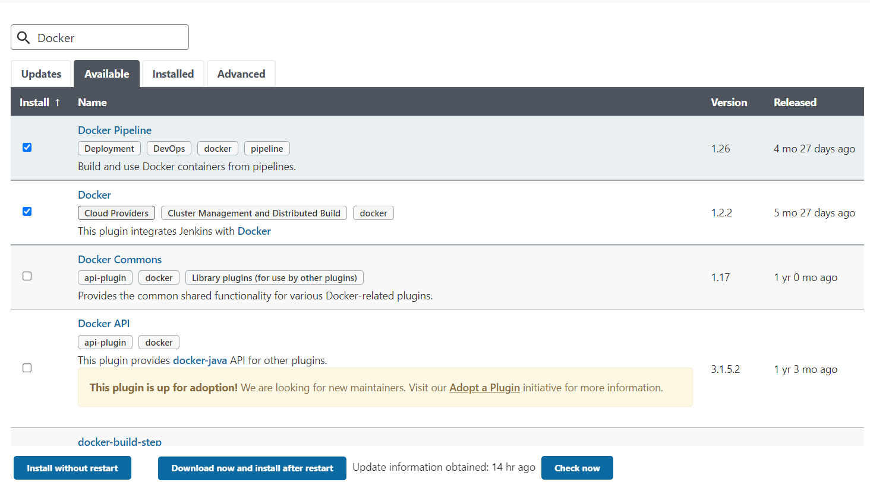

**Step 2: Navigate to Global Tool Configuration to add Maven and Docker Tool Configuration**

1. Navigate to Manage Jenkins and then click on Global Tool Configuration to add Both maven and Docker tool configurations.

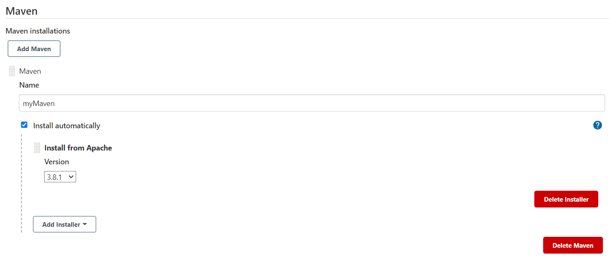

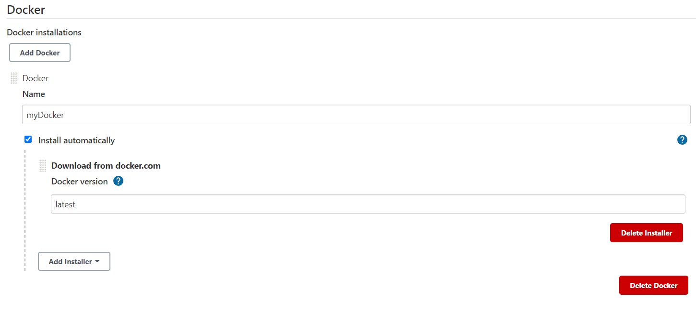

1. Configure Jenkins credentials with credential id **dockerHubAccount** for configuring Docker Hub username password for pushing Docker image.

**Note:** We have already learned how to create credentials in Lesson 4 Demo 2.

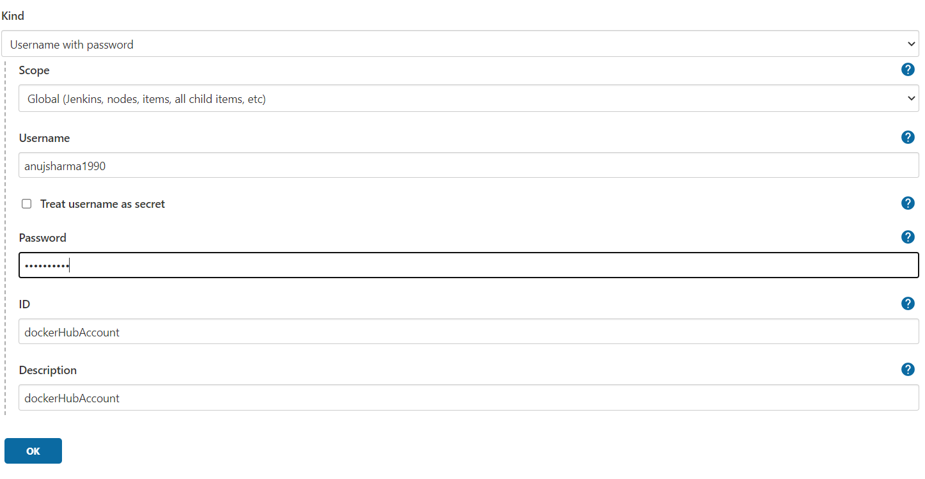

**Step 3: Configure Jenkins pipeline and execute build for Docker pipeline.**

1. Login to Jenkins CI tool with admin user and click on New Item to create new Jenkins’s job.

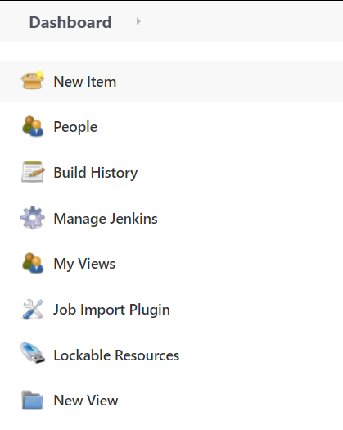

1. Select Pipeline project while creating Jenkins’s job and provide custom job name.

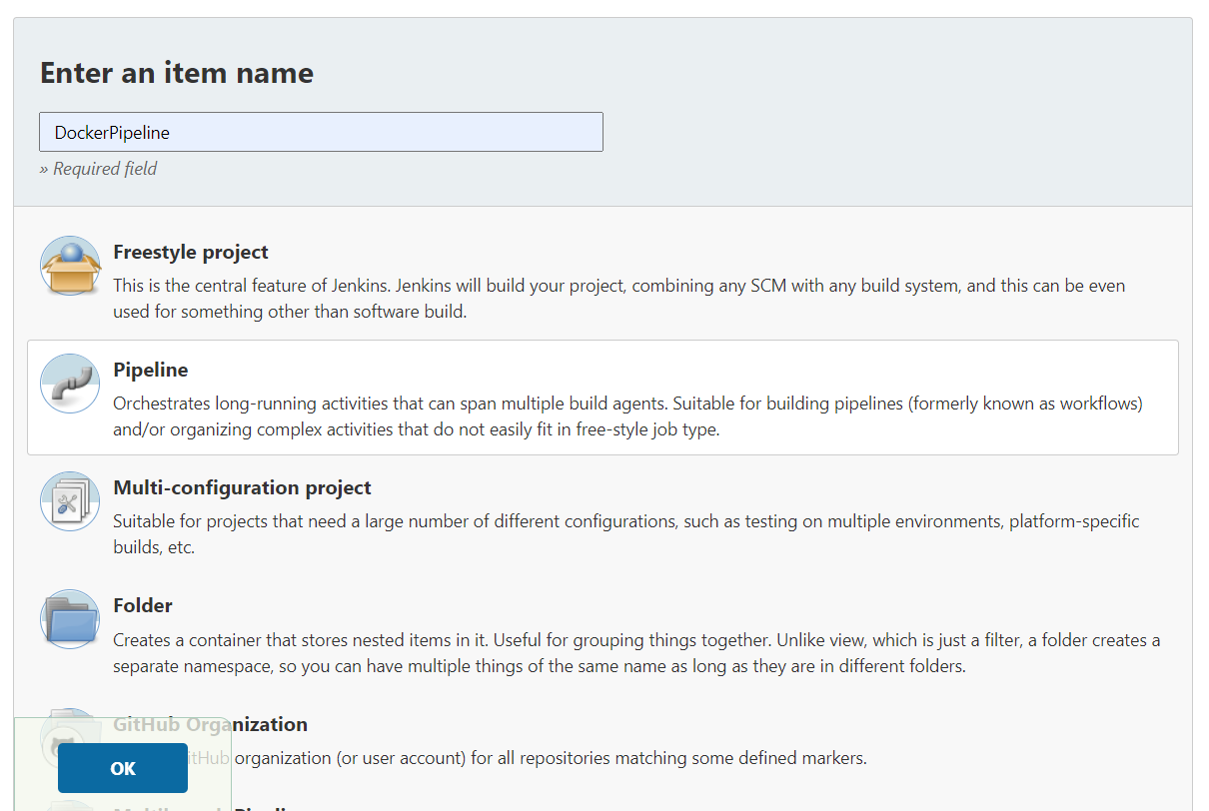

1. Once job name is provided, click on Ok button to save Jenkins’s job and a new configuration screen would be opened.

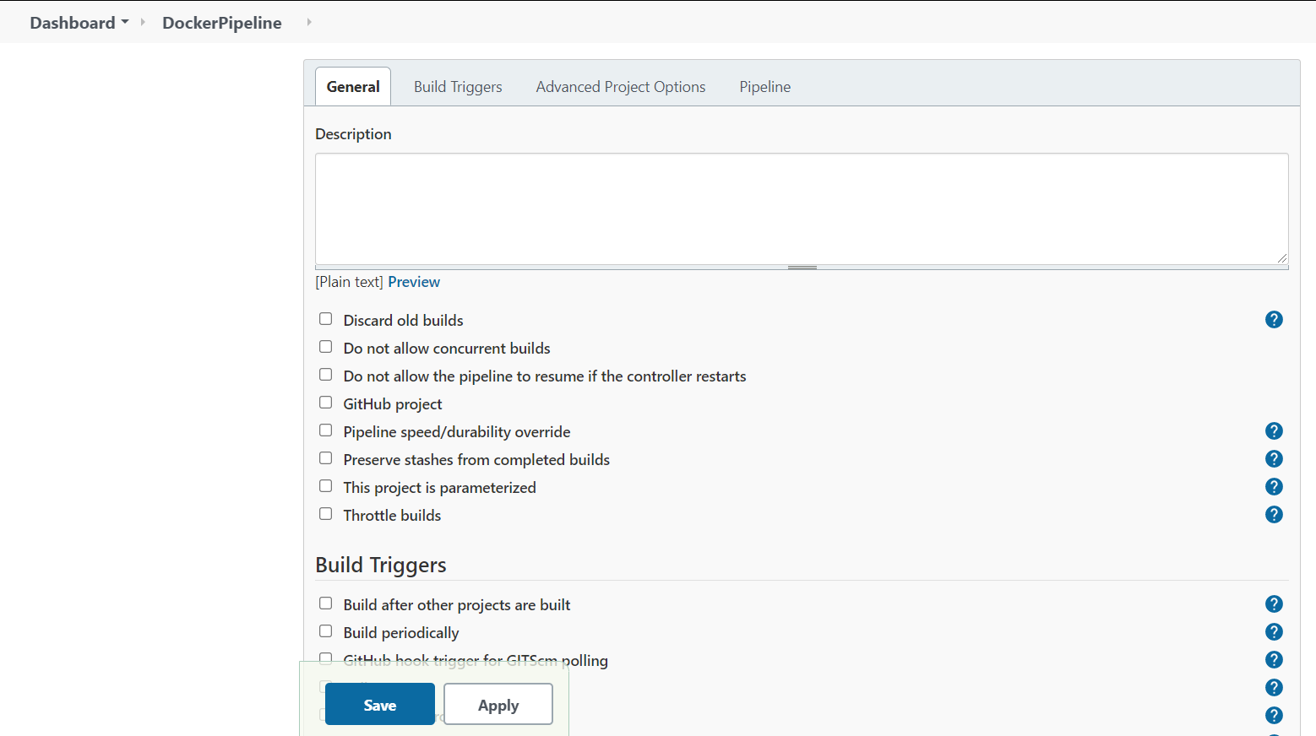

1. In configure screen you need to access Pipeline tab to provide Git repository configurations from where you want to checkout pipeline.

<https://github.com/anujdevopslearn/DockerPipeline.git>

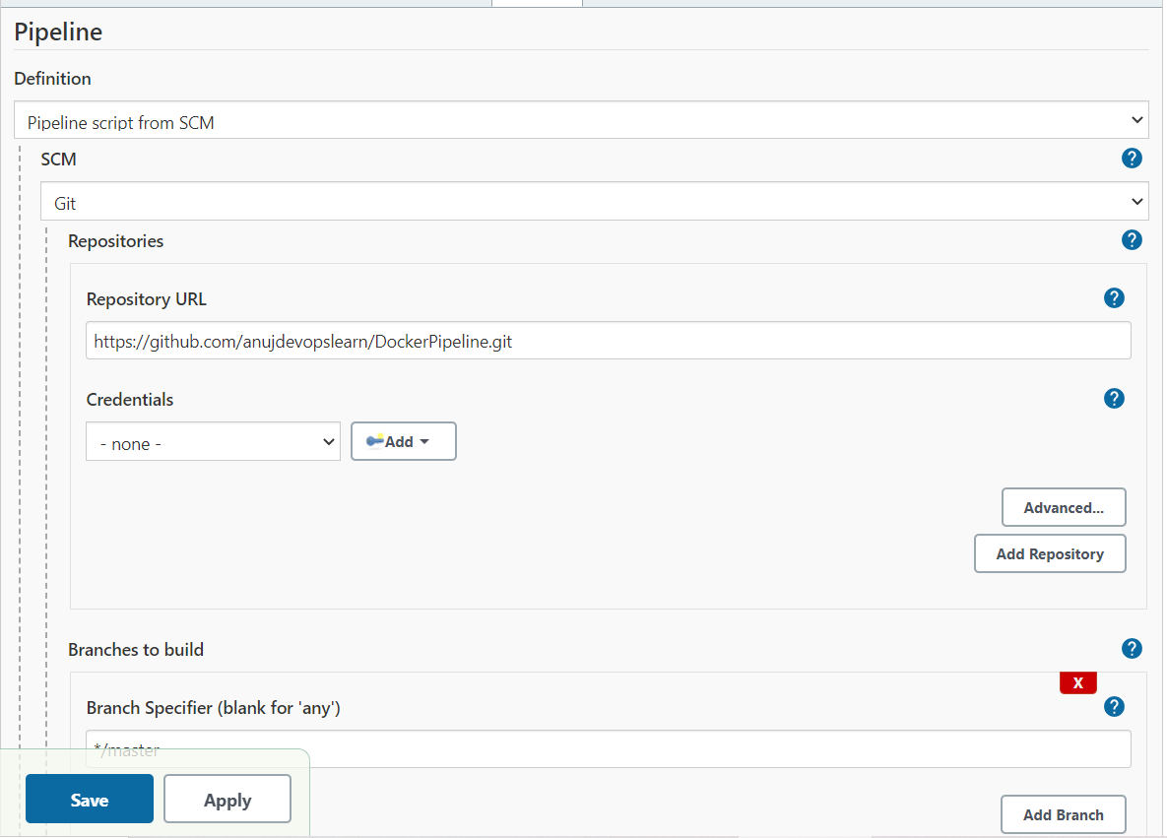

1. In case you are using different Pipeline script you can configure Script path in Pipeline project.

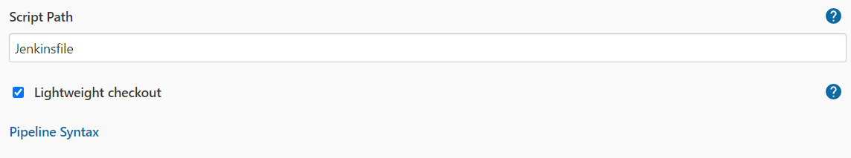

1. Once Git repositories configurations are configured in Jenkins’s job, you can trigger Jenkins’s job build.

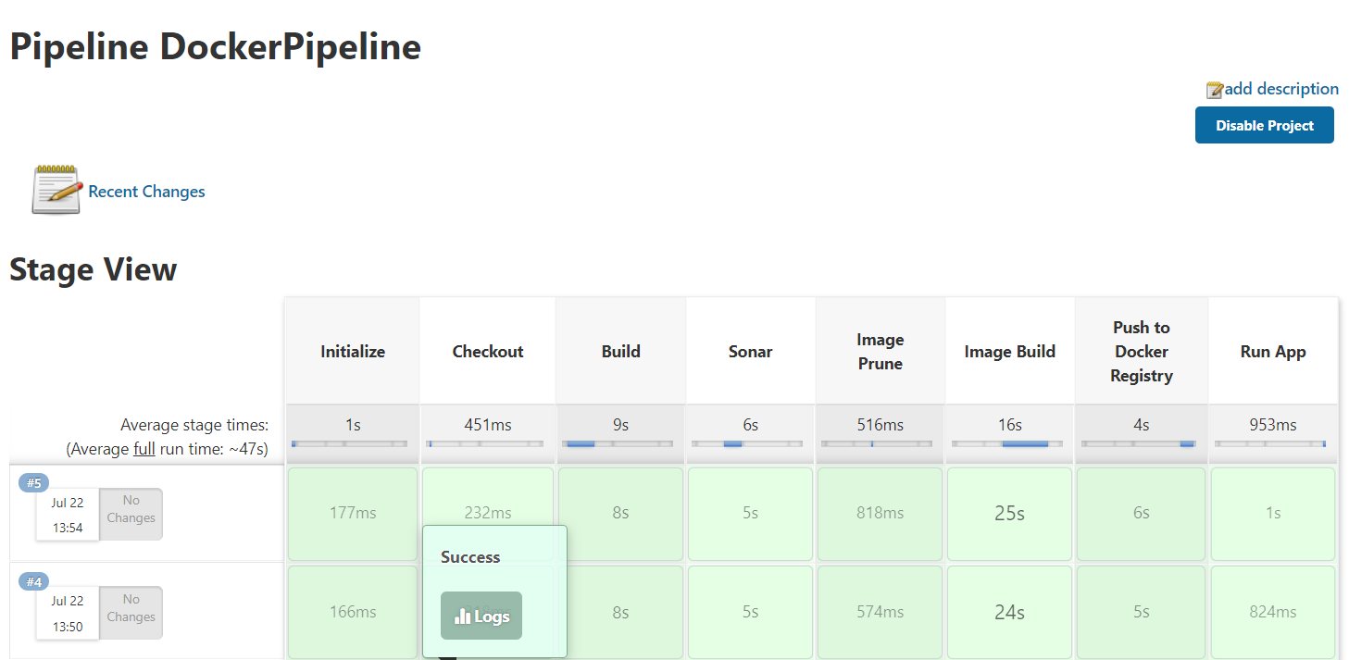

1. In case you got below error please provide permission to sock file to get a successful build.

Error:

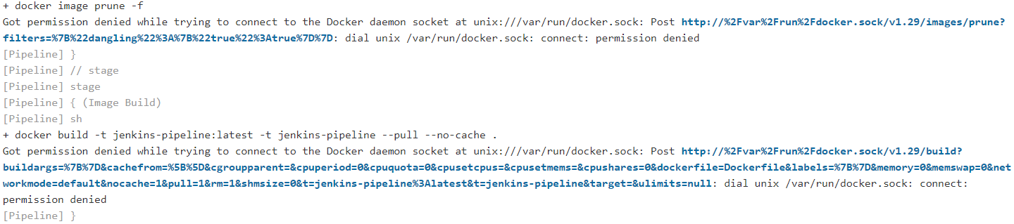

Command to fix error:

***chmod -R 777 /var/run/docker.sock***